Hardware Wallet
# Source: AI Source: Provided by: [Data Path: Persons Table -> ID Column: 1, Name_En Column: Motasem Essam] -> From: [ChatGPT] on [1/21/2026]
A Hardware Wallet is a physical device used to securely store cryptocurrency private keys offline. It is a type of cold wallet, offering maximum protection against online threats, making it ideal for long-term and high-value storage.

🔐 Key Characteristics of Hardware Wallets:
# Source: AI Source: Provided by: [Data Path: Persons Table -> ID Column: 1, Name_En Column: Motasem Essam] -> From: [ChatGPT] on [1/21/2026]
- Offline Storage
  - Keeps private keys completely offline, even during transaction signing.
  - Only signs transactions within the device, so private keys never leave the wallet.
- Physical Device Required for Access
  - Looks like a USB stick or small gadget, connects via USB or Bluetooth.
- Non-Custodial
  - Full ownership of keys rests with the user (no third-party control).
- Recovery Seed Phrase
  - Comes with a 12-24 word seed phrase for wallet recovery if lost or damaged.

📦 Popular Hardware Wallets:
# Source: AI Source: Provided by: [Data Path: Persons Table -> ID Column: 1, Name_En Column: Motasem Essam] -> From: [ChatGPT] on [1/21/2026]
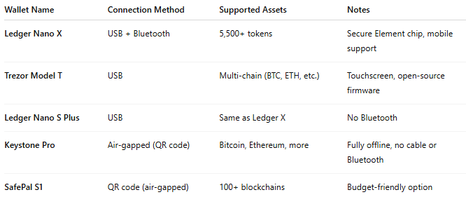

Wallet Name | Connection Method | Supported Assets | Notes
Ledger Nano X | USB + Bluetooth | 5,500+ tokens | Secure Element chip, mobile support
Trezor Model T | USB | Multi-chain (BTC, ETH, etc.) | Touchscreen, open-source firmware
Ledger Nano S Plus | USB | Same as Ledger X | No Bluetooth
Keystone Pro | Air-gapped (QR code) | Bitcoin, Ethereum, more | Fully offline, no cable or Bluetooth
SafePal S1 | QR code (air-gapped) | 100+ blockchains | Budget-friendly option

🛠️ How It Works:
# Source: AI Source: Provided by: [Data Path: Persons Table -> ID Column: 1, Name_En Column: Motasem Essam] -> From: [ChatGPT] on [1/21/2026]
- User sets up the device and writes down the recovery seed phrase.
- Funds are sent to the wallet’s public address.
- When sending crypto:
  - The unsigned transaction is created on a connected device (PC/mobile).
  - The hardware wallet signs the transaction offline.
  - The signed transaction is then broadcast online from the host device.
- At no point does the private key leave the hardware wallet.

✅ Advantages:
# Source: AI Source: Provided by: [Data Path: Persons Table -> ID Column: 1, Name_En Column: Motasem Essam] -> From: [ChatGPT] on [1/21/2026]
- Maximum security for crypto assets
- Immune to remote attacks, phishing, or keyloggers
- Compatible with many desktop, mobile, and browser wallets (e.g., MetaMask, Electrum)
- Ideal for long-term HODLing and large balances

⚠️ Disadvantages:
# Source: AI Source: Provided by: [Data Path: Persons Table -> ID Column: 1, Name_En Column: Motasem Essam] -> From: [ChatGPT] on [1/21/2026]
- Costs money (~$50–$300 depending on brand)
- Less convenient for daily transactions
- Physical loss or damage can result in loss of access (if not backed up)
- Requires backup of recovery phrase, which must be stored securely

🧠 Best Use Cases:
# Source: AI Source: Provided by: [Data Path: Persons Table -> ID Column: 1, Name_En Column: Motasem Essam] -> From: [ChatGPT] on [1/21/2026]
- Long-term crypto investors
- Users with large holdings
- Crypto holders concerned with security and self-custody
- Institutions storing crypto in cold storage

🆚 Hardware Wallet vs Other Wallet Types:
# Source: AI Source: Provided by: [Data Path: Persons Table -> ID Column: 1, Name_En Column: Motasem Essam] -> From: [ChatGPT] on [1/21/2026]
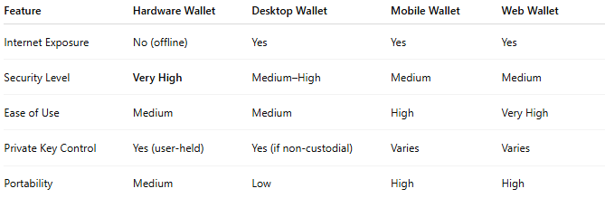

Feature | Hardware Wallet | Desktop Wallet | Mobile Wallet | Web Wallet
Internet Exposure | No (offline) | Yes | Yes | Yes
Security Level | Very High | Medium–High | Medium | Medium
Ease of Use | Medium | Medium | High | Very High
Private Key Control | Yes (user-held) | Yes (if non-custodial) | Varies | Varies
Portability | Medium | Low | High | High

🔐 Security Tips for Hardware Wallets:
# Source: AI Source: Provided by: [Data Path: Persons Table -> ID Column: 1, Name_En Column: Motasem Essam] -> From: [ChatGPT] on [1/21/2026]
- Buy only from official sources (to avoid tampered devices)
- Back up your seed phrase and store it in a secure, offline location
- Never store the seed phrase online or on your phone
- Use a PIN code and passphrase (if supported)
- Consider using a metal backup (e.g., Cryptosteel) for durability

